SWDPR301- PROJECT REQUIREMENTS ANALYSIS

DATE: Monday, 16th /06/2025
PERIOD: 08:30 AM – 11:30 AM


END OF TERM III EXAMINATIONS SCHOOL YEAR: 2024/2025
KIREHE ADVENTIST TVET SCHOOL(APAPEN)
SECTOR: ICT and MULTIMEDIA RQF LEVEL: L3
TRADE: SOFTWARE DEVELOPMENT MARKS: CAMIS:
………/100
………/50

DURATION: 3 HOURS

INSTRUCTIONS TO CANDIDATES:
This Exam paper is composed of Three Sections (A, B, C). Follow the instructions given below, and answer the indicated questions for a
total of 100 marks
Section A: Seventeen (17) questions, all Compulsory
55 marks
Section B: Among the five (5) questions, attempt any three (3) 30 marks
Section C: Among the two (2) questions, attempt any one (1)
15 marks
Allowed materials:
- Ruler, Blue or Black pen.

SECTION A: Attempt all questions (55 marks)
KIREHE ADVENTIST TVET SCHOOL(APAPEN)

01. | In software development and project management, understanding key terms is essential for addressing customer needs and delivering successful outcomes.  - What is the definition of a "Project"?  - A temporary endeavor undertaken to create a unique product, service, or result.  - A repeating activity conducted within daily business operations.  - A general plan for company growth.  - A business meeting to discuss progress.  - What is a "User Story"?  - A report showing monthly sales.  - A simple description of a feature from the user's perspective.  - A design layout for a product.  - A training manual for employees.  - What does the term "Task Flow" refer to?  - A budget report.  - A diagram showing team hierarchy.  - A sequence of steps taken to complete a task in a system.  - A customer satisfaction survey.  - What is a "Pain Point"?  - A checklist used for hiring employees.  - A successful marketing message.  - A development tool used for debugging.  - A specific problem faced by current or prospective customers.  - What is a "Project Requirement"?  - A project budget estimate.  - A table of team members' responsibilities.  - A software license agreement.  - A clear statement of what needs to be achieved in a project. | (5 Marks)

02. | Which of the following is a reliable source of customer needs in requirement analysis?  - Internal brainstorming sessions  - Product technical manuals  - Team scheduling documents  - Market research | (3 Marks)
03. | In software development and project management, remember key concepts is crucial for successful requirement analysis and stakeholder engagement. This knowledge helps ensure that projects meet user expectations and business needs.  Read the statements carefully and choose the correct answer.  - What is the primary objective of requirement analysis?  - To increase the project cost.  - To ensure that project deliverables meet user expectations and business needs.  - To delay the project timeline.  - To reduce stakeholder engagement.  - What is a User Persona?  - A fictional representation of an ideal user based on real data and research.  - A software tool used for coding.  - A project manager’s task list.  - A list of stakeholder names.  - Who is considered as primary stakeholder in a project?  - A random customer  - A competitor  - Project Sponsor  - A company not involved in the project  - What is the primary purpose of research? | (5 Marks)

- To express personal opinions
- To collect random information
- To discover new knowledge or verify existing facts
- To promote a product or service
- What is a customer?
  - A person who sells goods or services
  - A person or business who buys goods or services from a business.
  - A business that provides services to another business.
  - An employee working in a retail store.

04. | What is the main goal of data gathering in the context of customer needs among the following?  - To manipulate data for visualization.  - To collect accurate information about customer needs.  - To cleanse data for reporting purposes.  - To categorize data into specific groups. |  |  |  |  | (2 Marks)
05. | Match the following research methodologies with their  definitions: write corresponding number to answer column. |  |  |  |  | (4 Marks)
 |  | Methodologies | Definitions | Answer
 |  | A). Fundamental  Research | 1. Collects data  through | A=?
KIREHE ADVENTIST TVET SCHOOL(APAPEN)
questionnaires or
interviews
 |  | B). | E | xploratory | 2.In-depth analysis of specific instances or  projects | B=?
 |  | Research
 |  | C). Survey Research |  |  | 3. Explores new ideas or  Concepts | C=?
 |  | D). Case Studies |  |  | 4. Focuses on understanding basic  principles. | D=?
06. | Which of the following is primary purpose of identifying project requirements?  - To outline project scope  - To select a project management approach  - To gather stakeholder feedback  - To define project goals and objectives |  |  |  |  |  |  | (2 Marks)
07. | Read the following statement about Agile methodology and answer by True/False:  Agile project management is suitable for projects with well-defined requirements and minimal expected changes………………... | (2 Marks)
08. | Which of the following best describes the role of "Encoding" in the work communication process?  - Receiving and interpreting a message  - Translating the idea into a transmittable form.  - Providing a response to a received message.  - Selecting the appropriate communication channel. | (2 Marks)
09. | Read the following statements and choose the best correct answer.  - Which of the following best defines Accessibility Requirements?  - Ensuring that systems are easy to use for all users.  - Ensuring that people with disabilities can use the system effectively.  - Focusing on system performance and speed.  - Making sure that systems are only accessible to registered users.  - Which of the following is an example of an Accessibility  Requirement? | (5 Marks)

- Using a clear font style to improve readability.
- Providing a high contrast mode for visually impaired users.
- Allowing users to reset their password easily.
- Making the navigation bar visible at all times.
- What is the focus of Usability Requirements?
  - Making sure the system is secure.
  - Ensuring the system works for all user abilities.
  - Making systems easy to use and efficient for all users.
  - Making the system compatible with all devices.
- Which of the following is an example of a Usability Requirement?
  - Ensuring that all text is screen reader-friendly.
  - Ensuring that the system is intuitive and easy to navigate.
  - Providing subtitles for audio content. d)Implementing a dark mode for users with visual
impairments.
- What is the primary goal of both Accessibility and Usability Requirements?
  - To ensure that the system works on multiple devices.
  - b) To make the system easy to use and accessible for all users.
  - To improve the system's speed and performance.
  - To increase the number of users accessing the system.

KIREHE ADVENTIST TVET SCHOOL(APAPEN)

10. | Read the following paragraph carefully about customer needs and fill the correct term in blank:  Terms are: Pain, Project, Data, User, Raw.  Answer:  The process of gathering data on customer needs involves using various methods such as surveys and interviews to collect (1) …………data. This data is then analyzed to identify (2) ………… point, which are areas where customers experience frustration or difficulty. Understanding these pain points helps in creating effective (3) ………… stories that capture specific customer behaviors and goals. These user stories are essential for  developing (4) …… backlogs that guide project development. Finally, the insights from customer data are organized and reported to stakeholders through (5) …. . visualization tools. | (5 Marks)
11. | Which of the following is the primary function of a project backlog in Agile project management?  - To track employee attendance and performance.  - To manage the project's financial transactions.  - To maintain a prioritized list of project deliverables and tasks.  - To document the project's communication plan. | (3 Marks)
KIREHE ADVENTIST TVET SCHOOL(APAPEN)

12. | Which of the following best describes the purpose of a user story in project development?  - To define the technical architecture of the system.  - To describe a feature from the user's perspective.  - To outline the project budget and timeline.  - To document the project's risks and mitigation strategies. | (2 Marks)
13. | An e-commerce platform needs to sketch a new checkout process to reduce abandonment rates. How can they use user testing to validate the effectiveness of this new process?  - Create a visual representation of the proposed checkout flow and validate it with internal stakeholders.  - Conduct user testing to gather feedback on the new process and identify usability issues.  - Refine the process immediately during the testing session based on feedback.  - Implement the new process and ask users for feedback after using it in production. | (2 Marks)
14. | A mobile app development team has defined user stories for a new feature, but user feedback shows the feature is confusing and hard to use. What is the most effective first step the team should take to improve the task flow and user experience?  - Conduct user testing of the current task flow to  identify usability issues | (3 Marks)

- Redesign the feature to be more visually appealing, without changing the task flow
- Provide clearer instructions for each step in the task flow
- Remove all optional features to focus only on the core functionality

15. | A marketing team wants to interpret user feedback to improve the user experience of their website. Which of the following is the most effective step to take during user testing to gather actionable insights?  - Conduct testing sessions with only one participant to reduce confusion  - Observe user behavior during the session and ask for feedback afterward  - Analyze feedback immediately and change the website in real-time  - Use team opinions instead of user feedback to make improvements | (3 Marks)
16. | Put the following steps in the correct order for organizing customer needs:  - Data Reporting  - Categorization of Data  - Data Collection  - Data Cleansing | (4 Marks)
17. | A project backlog contains a large number of user stories. Which of the following is the best way to prioritize the items in the backlog?  - Sort them alphabetically by title.  - Ask the development team to estimate the effort for each story and sort by effort.  - Work with the product owner and stakeholders to rank stories based on business value and urgency.  - Randomly select stories to work on to keep the team engaged. | (3 Marks)
KIREHE ADVENTIST TVET SCHOOL(APAPEN)

Section B: Attempt any three (3) questions (30 marks)
KIREHE ADVENTIST TVET SCHOOL(APAPEN)

18. | You are a business analyst tasked with improving the data-gathering process for a company that offers financial services to customers. The company aims to enhance its understanding of customer needs and pain points to provide better services within budget constraints.  Analyze the different types of data collection tools available for gathering customer feedback in the financial services  industry. Compare the strengths and weaknesses of these tools in terms of effectiveness, cost, and ease of implementation. Provide examples of suitable tools and justify your choices. | (10marks)

19. | Compare and contrast functional and non-functional  requirements by analyzing their roles, characteristics, and impact on software development. Provide examples to support your analysis. | (10marks)
KIREHE ADVENTIST TVET SCHOOL(APAPEN)

20. | Differentiate between user stories and use cases in the context of user requirements analysis. How do these tools relate to understanding user needs? | (10marks)

21. | When evaluating different communication channels for gathering customer feedback, it is essential to consider various factors to ensure that the feedback collected is relevant, representative, and actionable.  As a project manager:  - Evaluate each of the following factors and explain how each might impact the effectiveness of the feedback process: (4marks)  - The cost of the channel  - The popularity of the channel  - The ease of use of the channel  - The target audience's preferred method of communication and the type of feedback sought  - Justify why D is the most critical factor, using practical scenarios and customer engagement principles. (3marks)  - Provide three relevant examples to support your reasoning. (3marks) | (10marks)

22. | After gathering project requirements through surveys and interviews, you find that stakeholders are still unclear about the project's scope.  As a project manager:  - Assess the situation by identifying the potential risks of proceeding without a clear scope and the impact of each option. (6 Marks)  - Evaluate the available options (proceeding with the project, conducting further research, blaming stakeholders, or abandoning the project) and provide a detailed justification for your preferred course of action.  (4 Marks) | (10marks)

23. | Create a project backlog for a software development project that includes features for user authentication and data encryption. How would you assemble these features into a prioritized list and ensure they meet user requirements? | (15marks)
24. | Design a site map for an e-commerce website that includes sections for product categories, search, and user account management.  Answer:  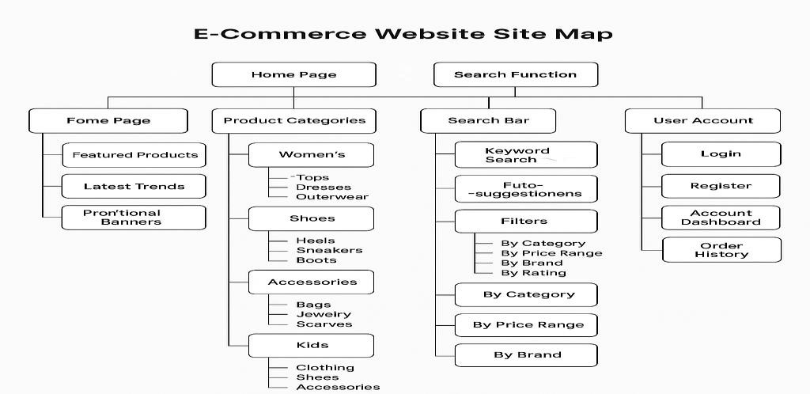 | (15marks)
Section C: Attempt only one (1) question (1

